ABIRAMI K

230701008 CSE-A

EXP 4 AWK SCRIPT

EXP 4A EMPLOYEE AVG PAY

PROGRAM:

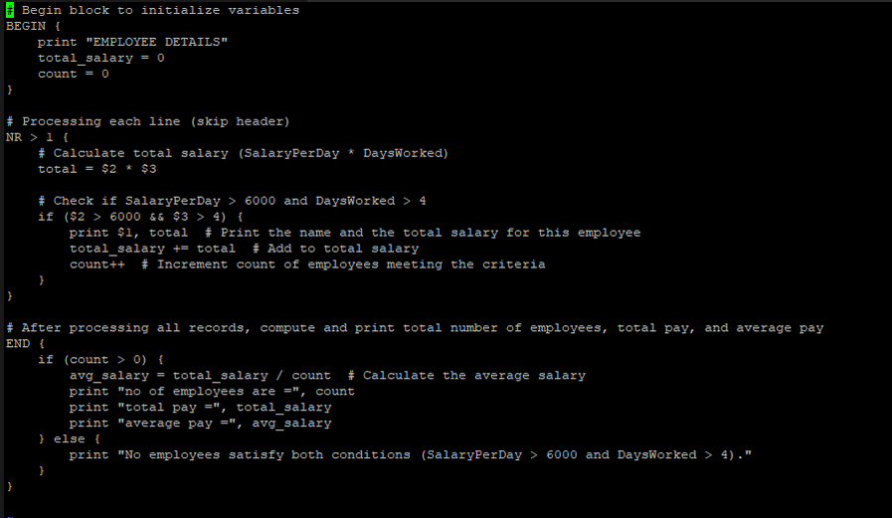

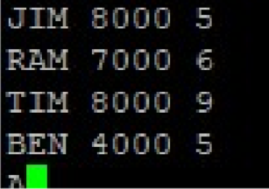

OUTPUT:

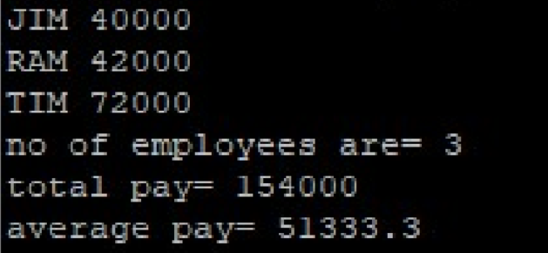

EXP 4B RESULTS OF AN EXAMINATION

PROGRAM:

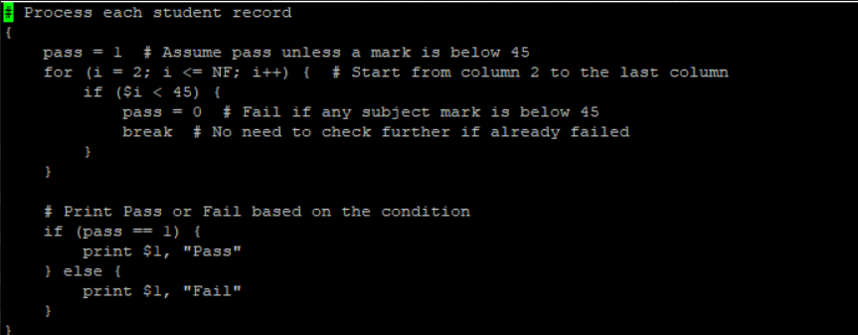

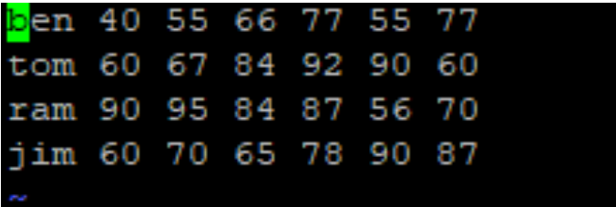

OUTPUT:

